**April 12th, 2021.**

SANSZEROS, LLC (USA) original ideas and concepts shared with Hafiza Anum Maqsood, Creative Designer (PAKISTAN) via Upwork.com

**PROJECT 1: City Elite or CIEL**

**Description:** The concept of City Elite or CiEl is to give the dynamic generations a way to be proud of themselves. Basically, I am an Elite of my City 😊. It can be printed as logo of just simple wording.

**Apparel and Fashion Designs**

+ Brands: **City Elite , CiEl**

**Main Brand:** City Elite **Derivative Brand: CiEl**

* The concept of City Elite is to design a brand that is luxury enough and yet simple and appealing to all, if not, people who are proud of their origins. These people are the “Elite” of their “City”.
* Applicable to all wearables and adaptable to seasons; i.e. shirts all sorts, shorts, jogging, sport, foot wears, belt, eyeglasses.....
* Some example as follow:

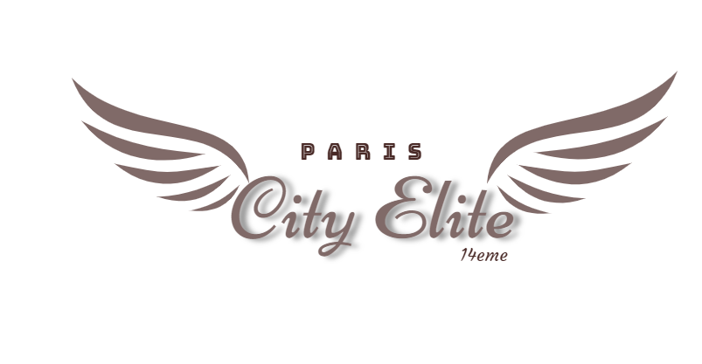

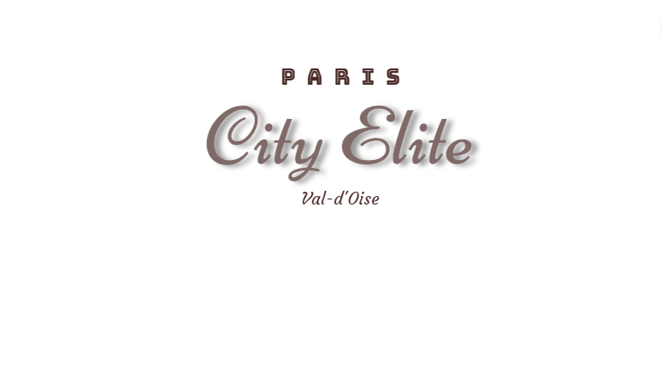

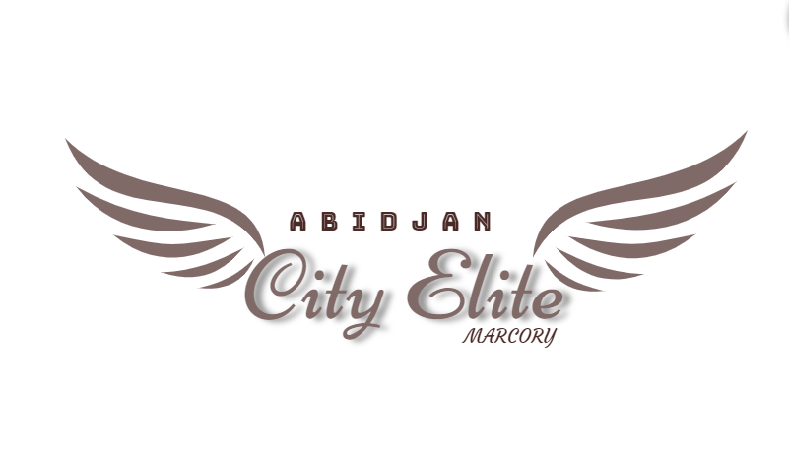

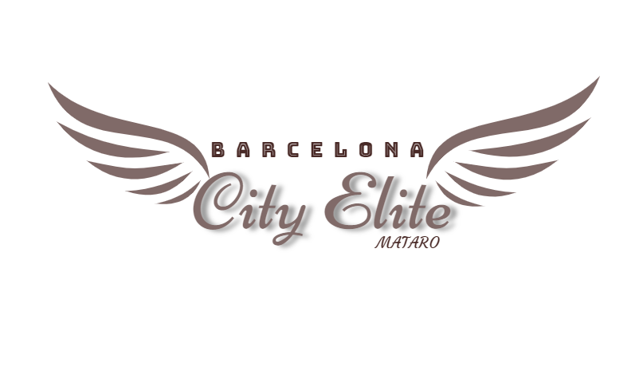



The word “City Elite” written in Niconne font charaters

The word “ISLAMABAD” is written in Bungee Inli font charaters

The word “Islamabad Capital Territory, Pakistan” is written in “Courgette”

The word “Ciel” which is the short cut of “**Ci**ty **El**ite” is written in Audiwide font characters

It’s basically the concept of City Elite written in the cloud. Again, CiEl = City Elite







